Midterm Exam

1. There are seven offices in the Classic Models ERD database.

select

officeCode,

city,

state,

country

from offices;

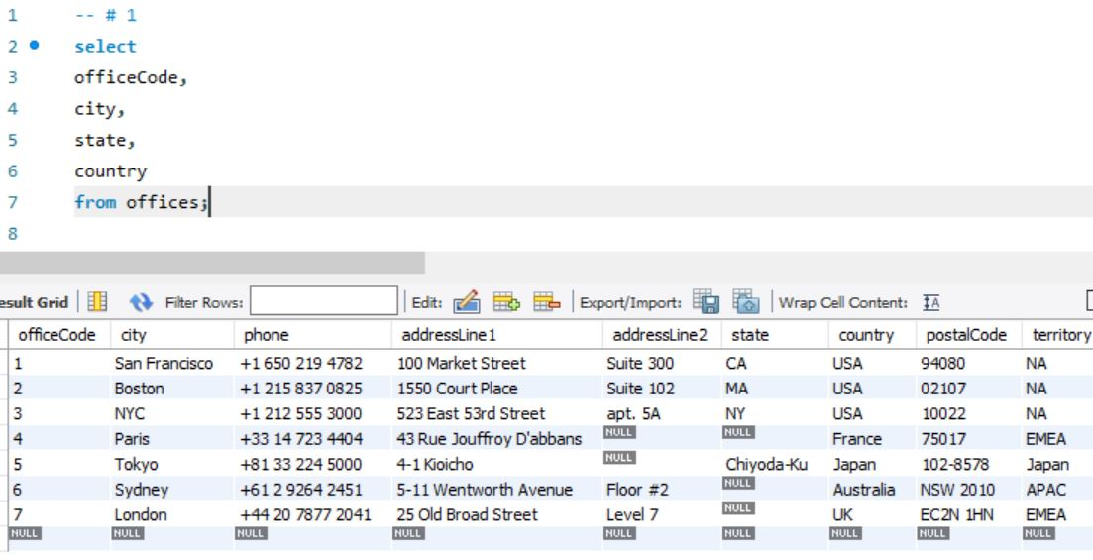

1. There are six employees working in the San Francisco office.

select

e.employeeNumber,

concat(e.firstName,' ',e.lastName) as 'Name'

from offices o

left join employees e

on o.officeCode = e.officeCode

where o.officeCode = 1;

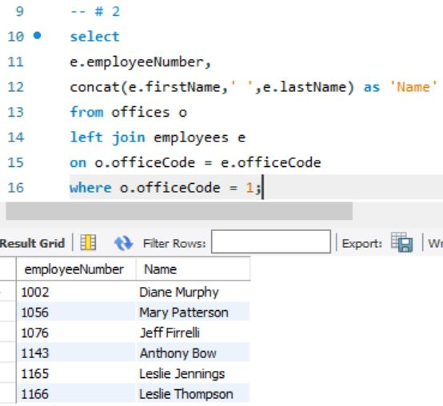

1. Australian Collectors, Inc. placed five orders with our company.

select

o.orderNumber,

o.orderDate

from orders o

left join customers c

on o.customerNumber = c.customerNumber

where c.customerNumber = 114;

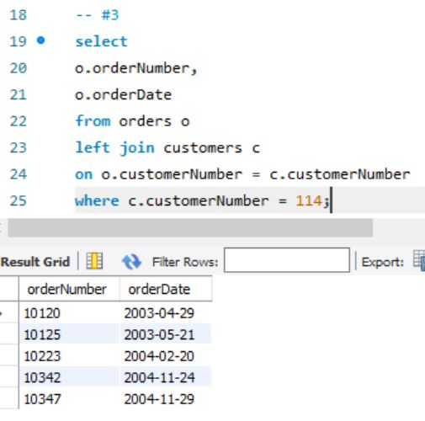

1. Australian Collectors, Inc. made four payments to our company.

select

p.checkNumber,

p.paymentDate,

format(p.amount, 2) as 'Amount'

from customers c

left join payments p

on c.customerNumber = p.customerNumber

where c.customerNumber = 114

order by paymentDate;

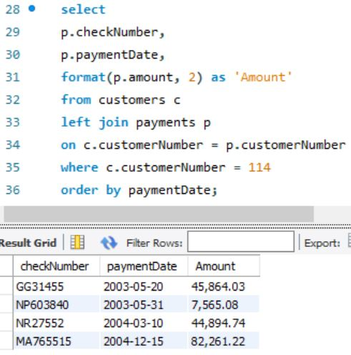

1. The total amount for Australian Collectors, Inc. placed on November 24, 2004 is $40,266.

select

c.customerName,

o.orderDate,

format(sum(od.quantityOrdered\*od.priceEach), 0) as 'Amount'

from customers c

left join orders o

on c.customerNumber = o.customerNumber

left join orderdetails od

on o.orderNumber = od.orderNumber

where c.customerNumber = 114

and o.orderDate = '2004-11-24'

group by o.orderDate;

